SAP FI | GUI Configuration |
Enterprise Structure user manual

Intern
Shriganesh Marewar

Contents
COMPANY CREATION 3
COMPANY CODE CREATION 6
BUSINESS AREA CREATION 8
ASSIGN COMPANY CODE TO COMPANY 10
FUNCTIONAL AREA CREATION 12
CREDIT CONTROL AREA CREATION 14

COMPANY CREATION:
To create company follow below steps:

SAP CONFIGURATION PATH:
SPRO > SAP Reference IMG > Enterprise Structure > Definition > Financial Accounting > Define Company

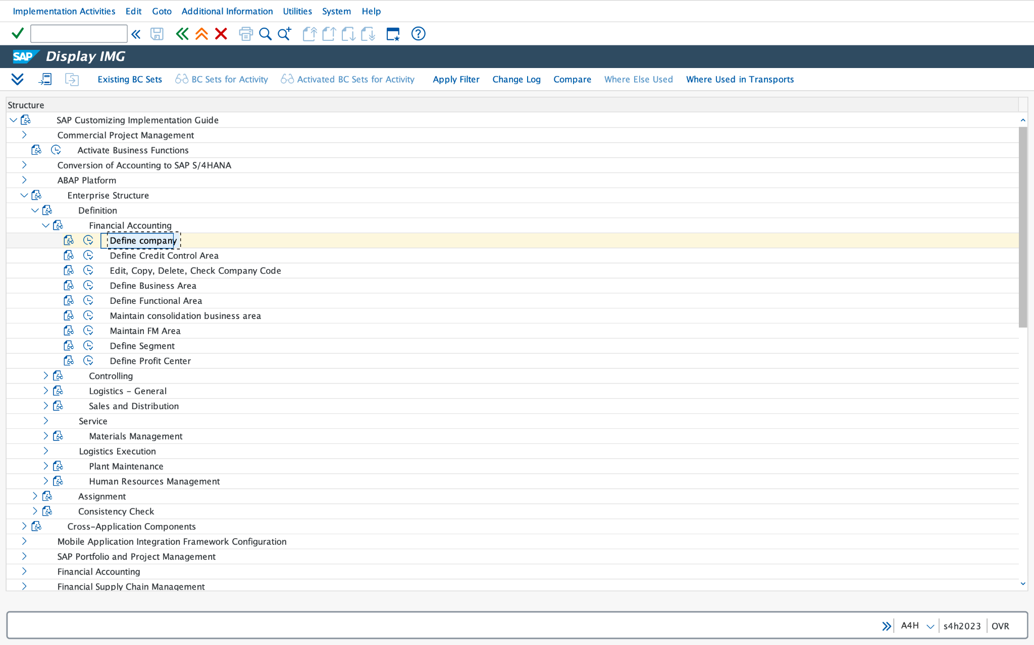

TRANSACTION CODE:

OX15

Required fields are shown in the image please fill up the required fields.

Company (R): please type the name of your company.

Company name (R): please write the name for your company.

Name of Company 2 (O): please write the name of Company 2 for your company or you can skip the Name of Company 2.

Detailed Information(R):

Please fill up the detailed information as per image.

Street (R): Please fill up the respective street address as per your company.

PO Box (R): Please fill up the respective PO Box address as per your company.

Postal Code (R): Please fill up the respective Postal Code as per your company.

City (R): Please fill up the respective City as per your company.

Country/Region (R): Please fill up the respective Country/Region as per your company.

Language Key (R): Please fill up the respective Language as per your company.

Currency (R): Please fill up the respective Currency as per your company.
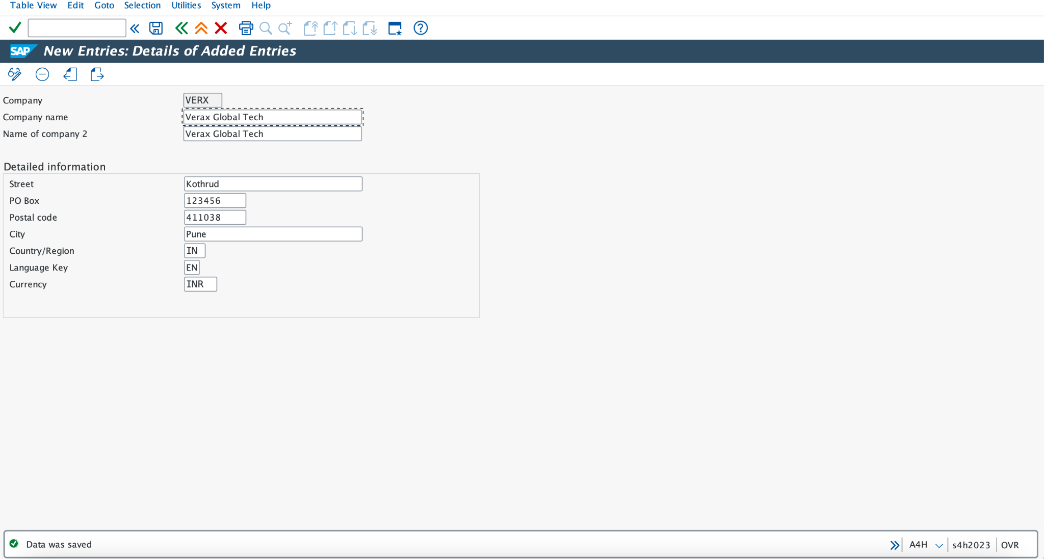

COMPANY CODE CREATION:
To create company code follow below steps:

SAP CONFIGURATION PATH:
SPRO > SAP Reference IMG > Enterprise Structure > Definition > Financial Accounting > Edit, Copy, Delete, Change Company Code

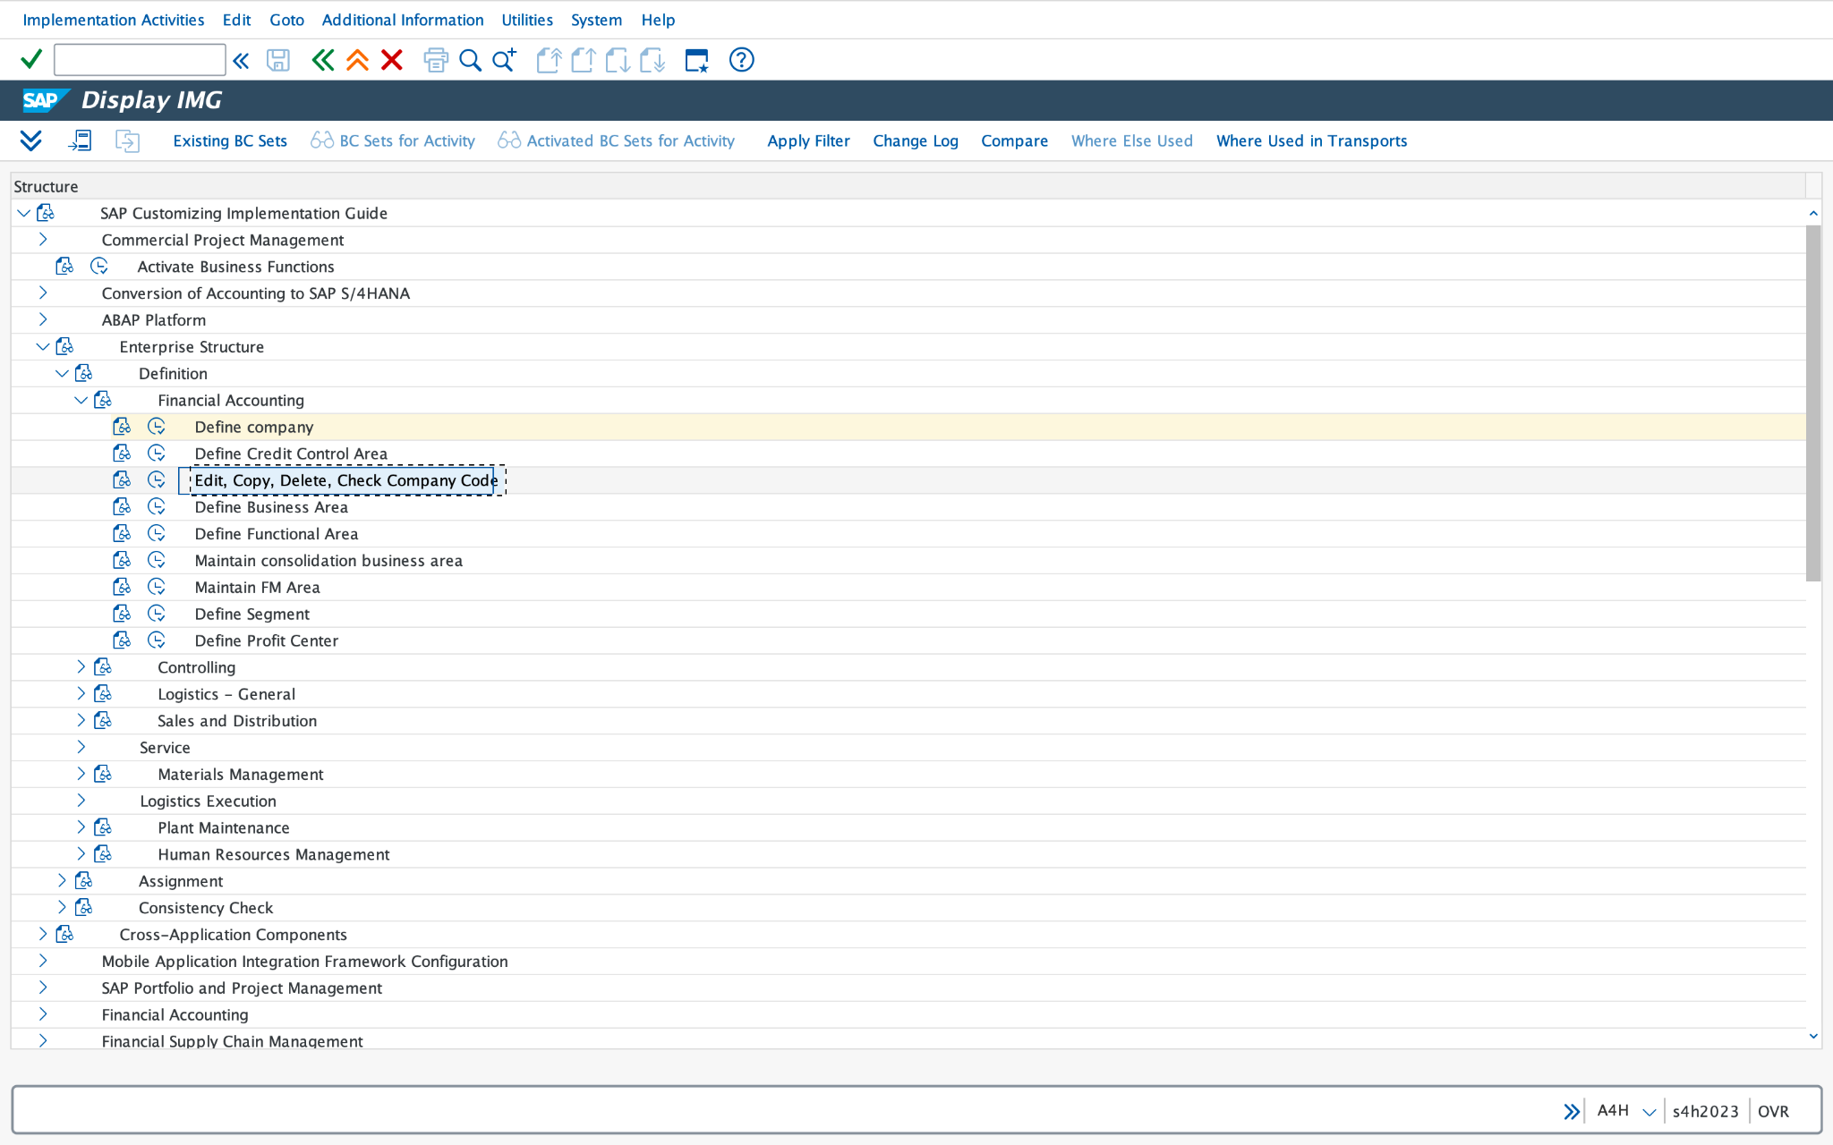

TRANSACTION CODE:

OX02

Required fields are shown in the image please fill up the required fields.

COMPANY CODE (R): please write Numeric Code for Company Code Name.

COMPANY NAME (R): please write Numeric Code for Company Code Name.

ADDITIONAL DATA(R):

City (R): Please fill up the respective City as per your company Code.

Country/Region (R): Please fill up the respective Country/Region as per your company Code.

Currency (R): Please fill up the respective Currency as per your company Code.

Language Key (R): Please fill up the respective Language as per your company Code.

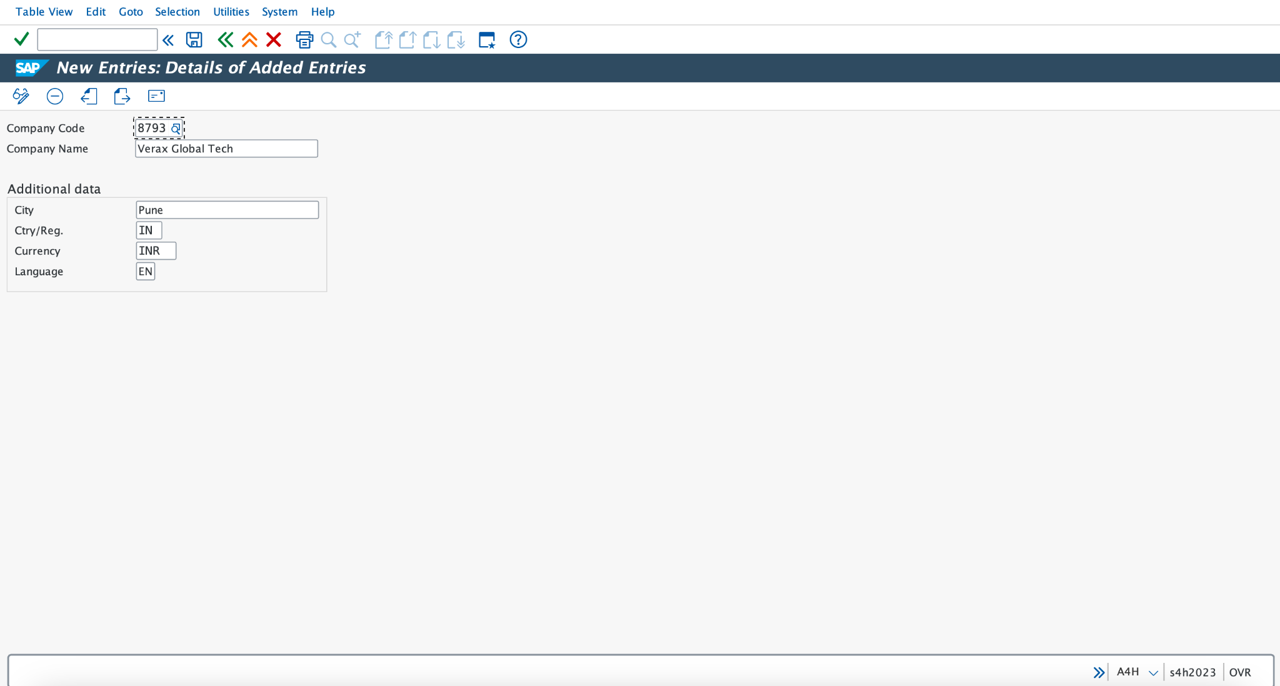
SAP TABLE FOR COMPANY CODE OX02:
T001

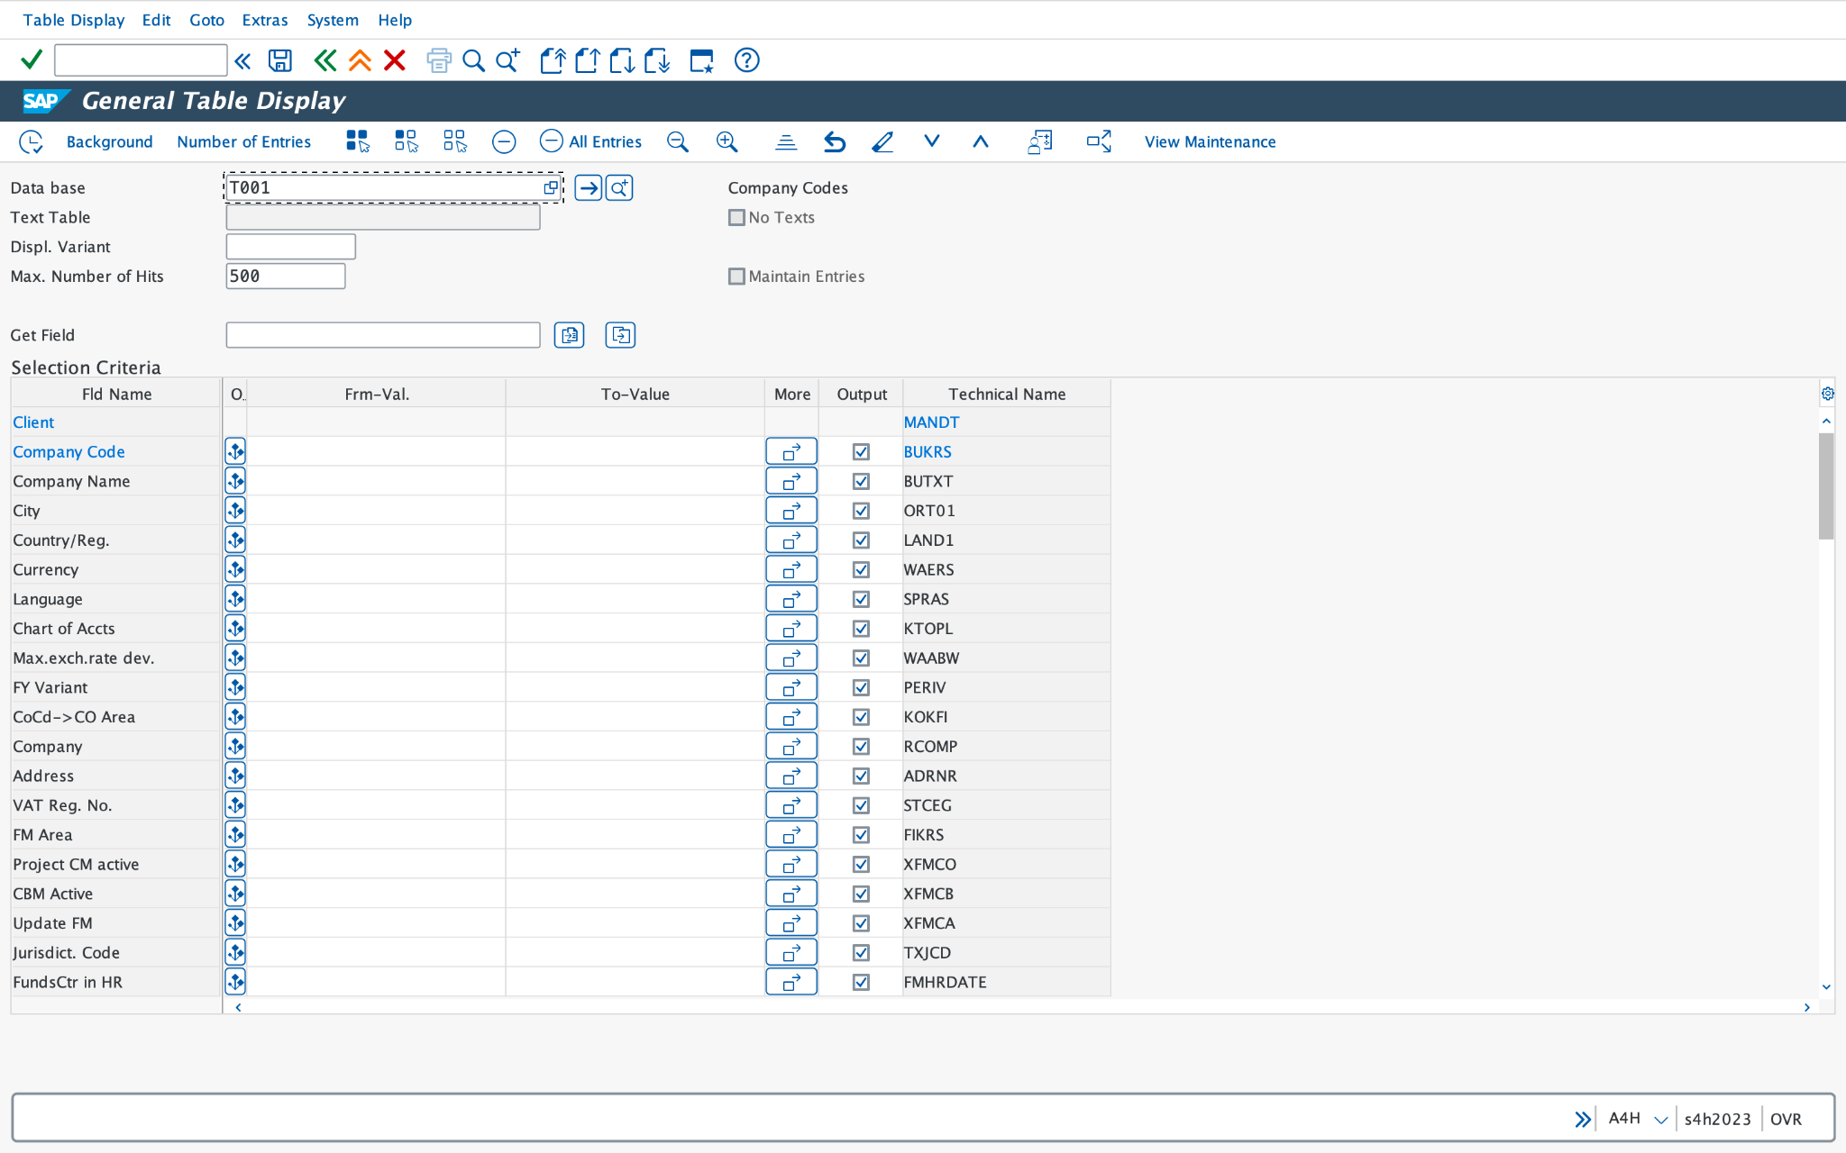

BUSINESS AREA CREATION:

SAP CONFIGURATION PATH:
SPRO > SAP Reference IMG > Enterprise Structure > Definition > Financial Accounting > Define Business Area

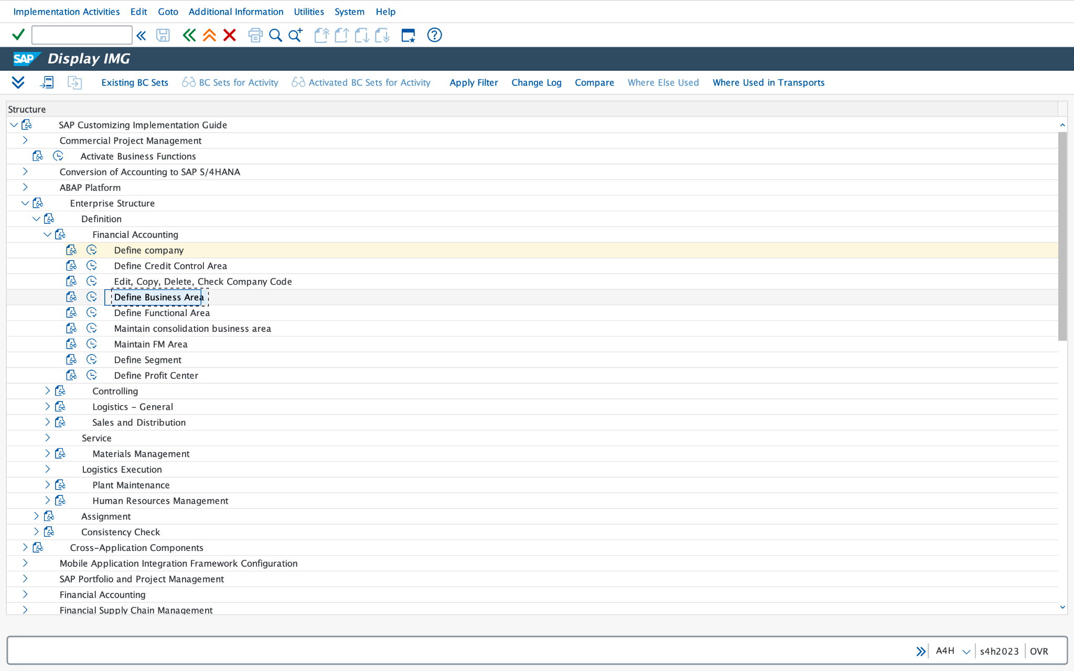

TRANSACTION CODE:

OX03

Required fields are shown in the image please fill up the required fields.

BUSINESS AREA COLUMN (R) and DESCRIPTION (R): fill up the numeric value for respective business area and Name of business area For ex 8793 and Pune.

And save it.

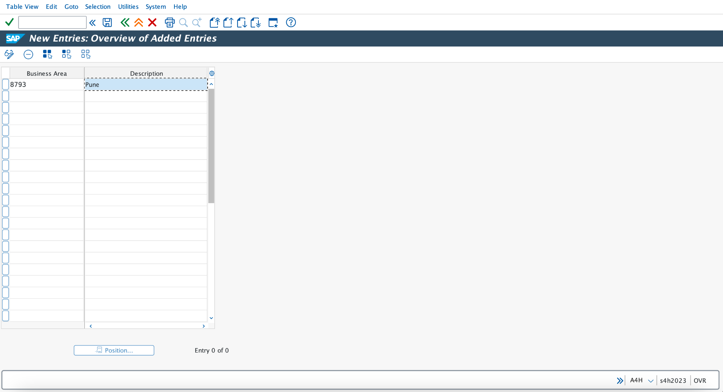

SAP TABLE FOR BUSINESS AREA OX03:
TGSB

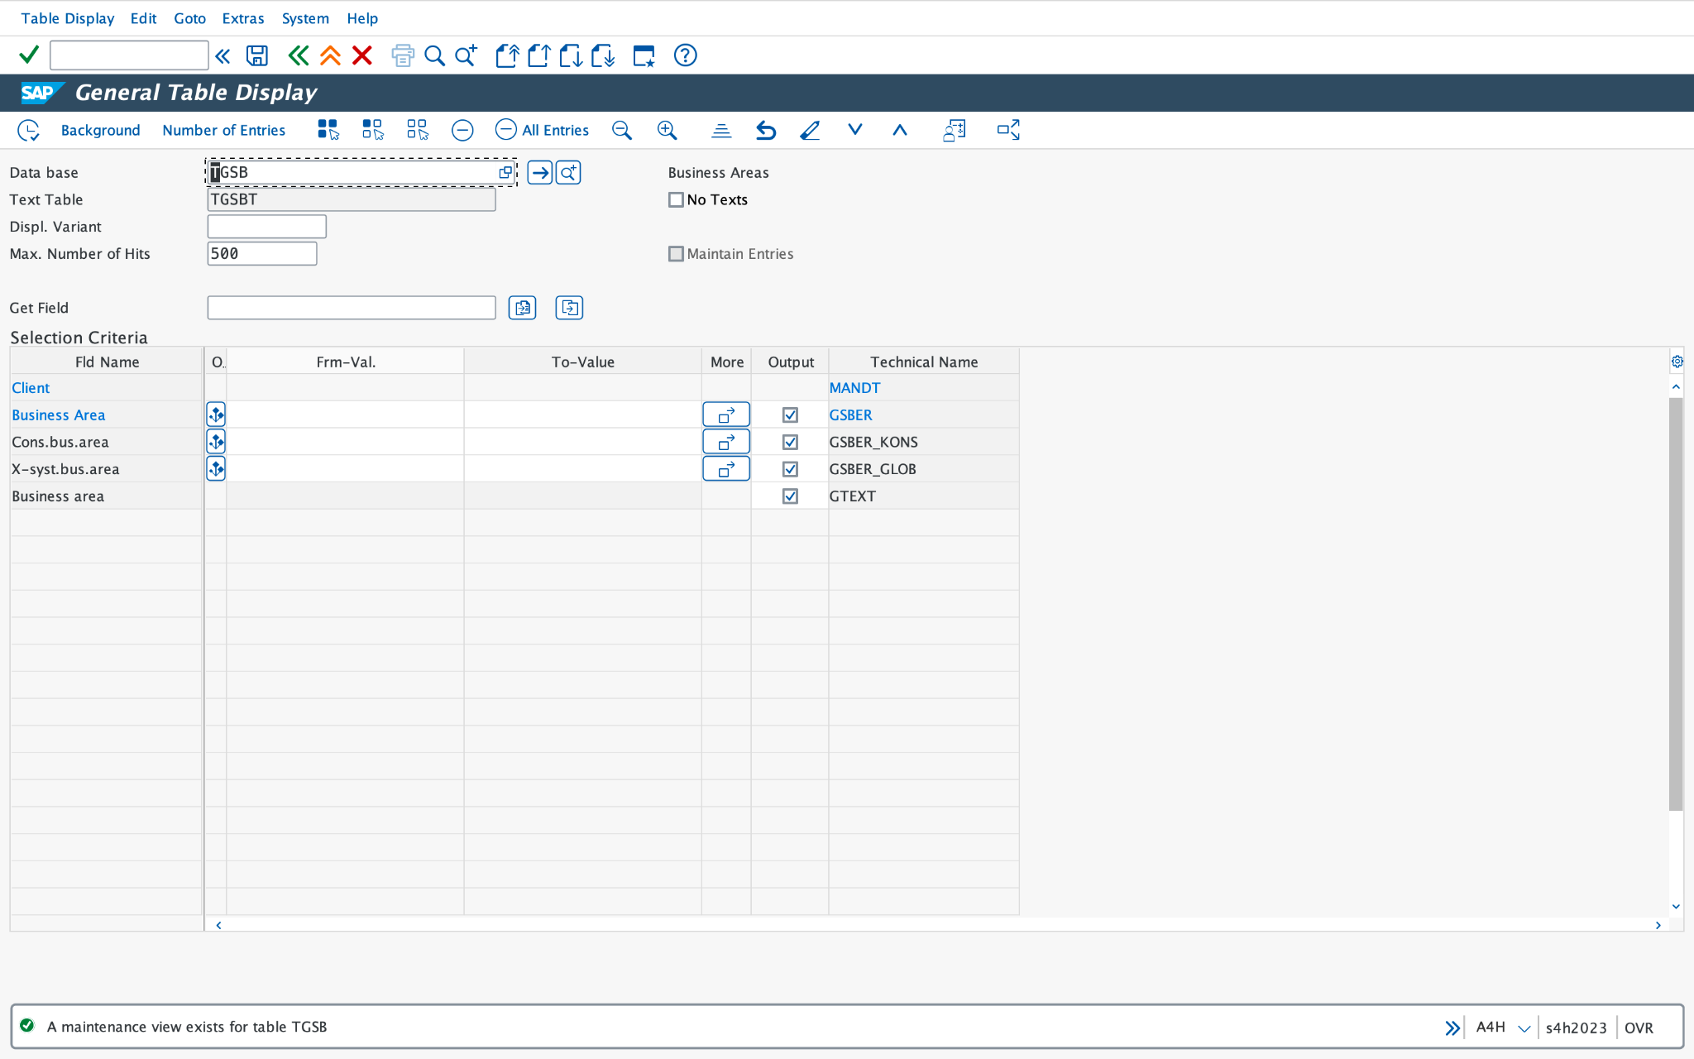

ASSIGN COMPANY CODE TO COMPANY

SAP CONFIGURATION PATH:
SPRO > SAP Reference IMG > Enterprise Structure > Assignment > Financial Accounting > Assign Company Code to Company.

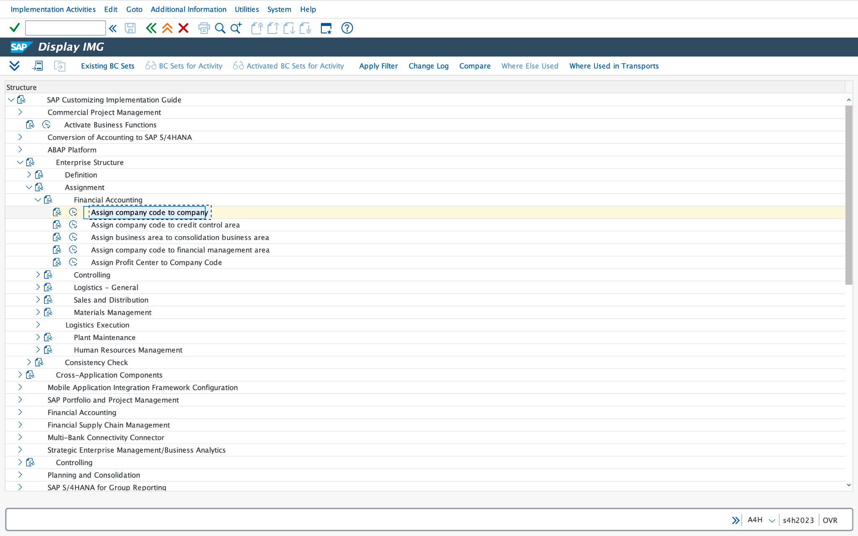

TRANSACTION CODE (R):

OX16

Company Column(R):

Please write a short company name in the column to assign company code to company.

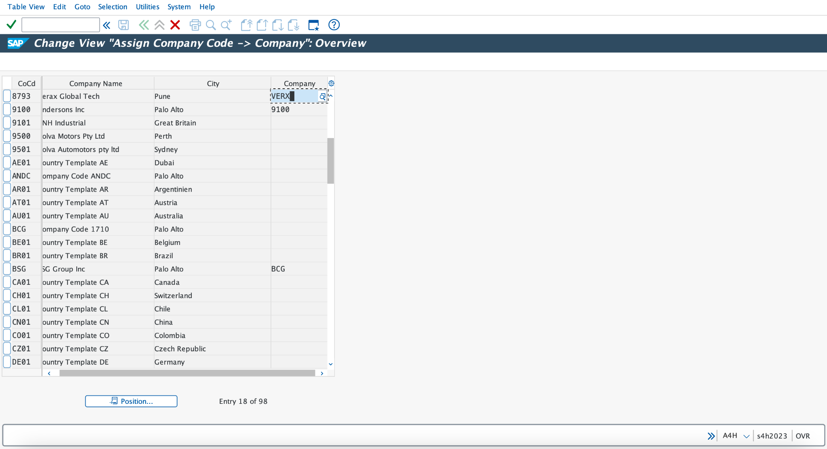

SAP TABLE FOR COMPANY CODE OX02:
T001



FUNCTIONAL AREA CREATION:

SAP CONFIGURATION PATH:
SPRO > SAP Reference IMG > Enterprise Structure > Definition > Financial Accounting > Define Business Area

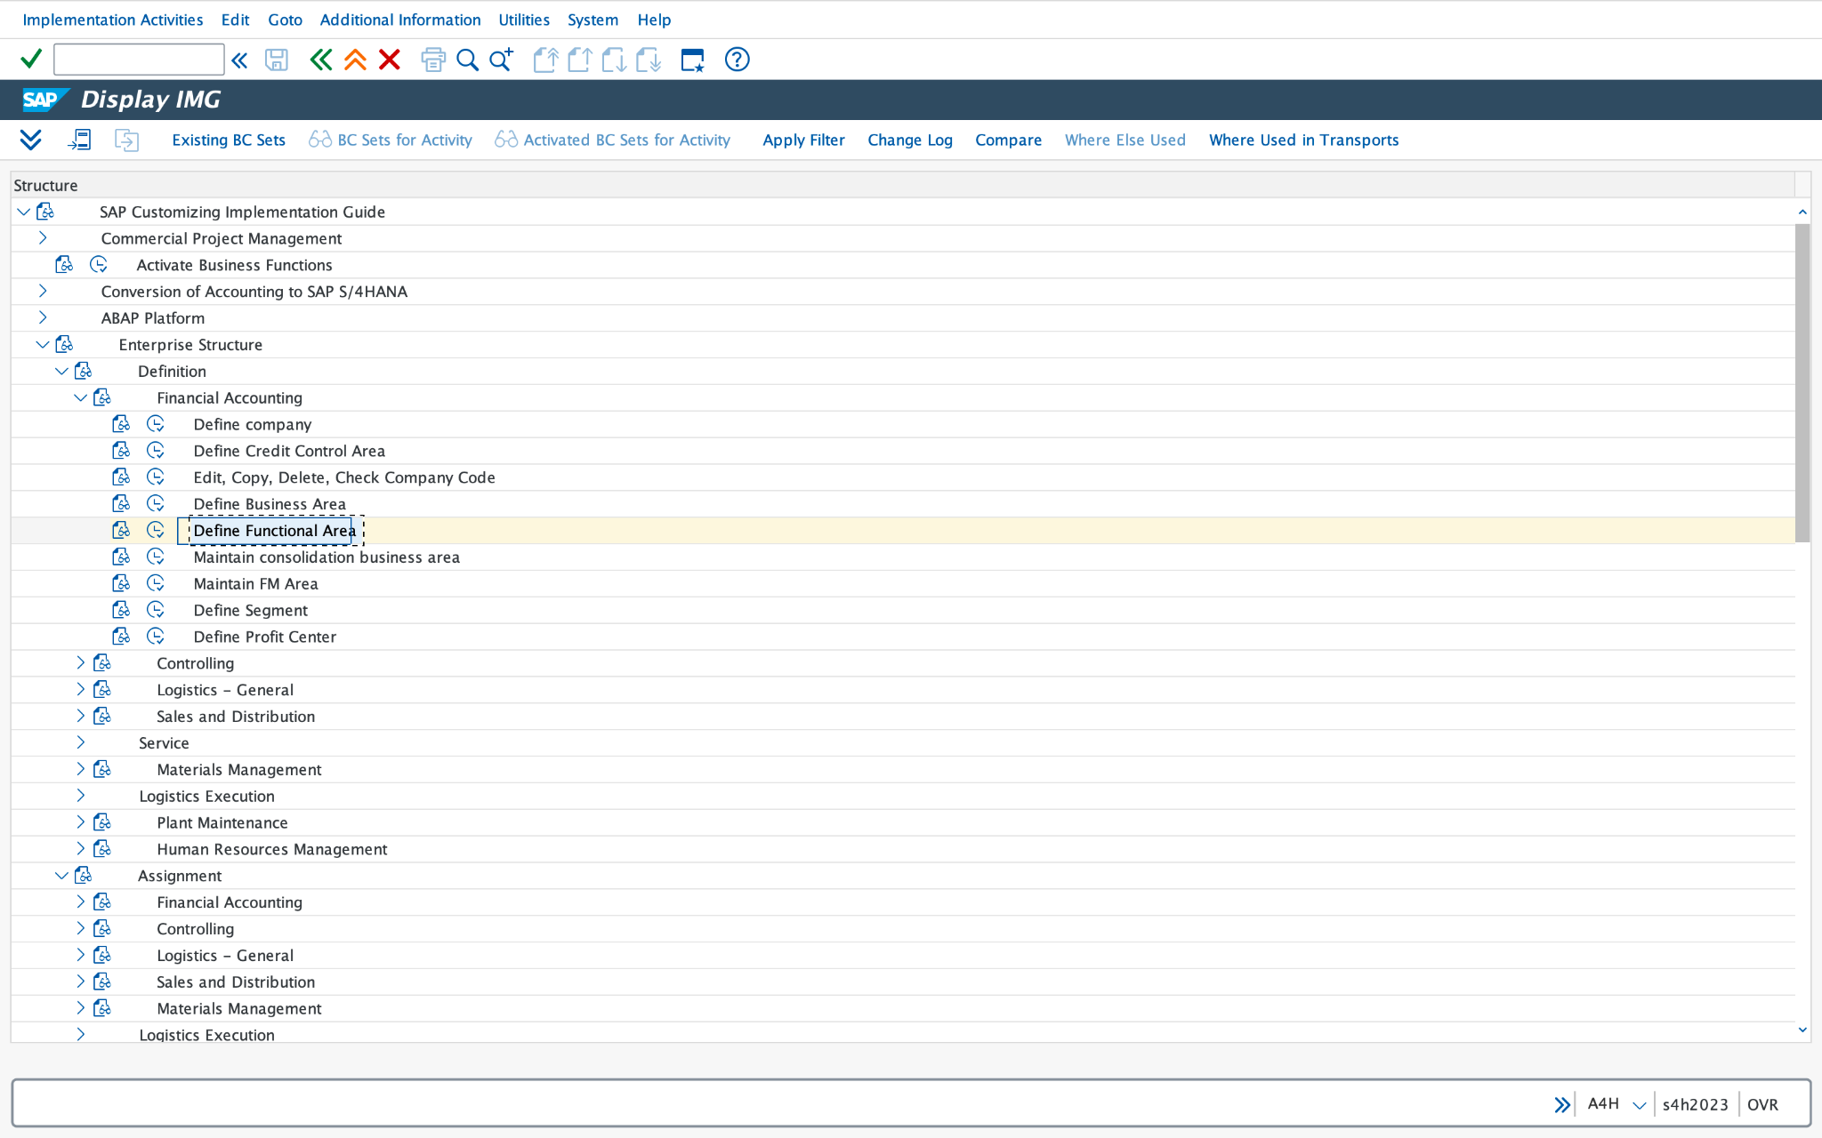

TRANSACTION CODE:

FM_FUNCTION

Required fields are shown in the image please fill up the required fields.

FUNCTIONAL AREA COLUMN (R) and NAME (R): fill up the numeric value for respective functional area column and Name of Functional Area For ex 8793 and Functional Area 8793.

And save it.

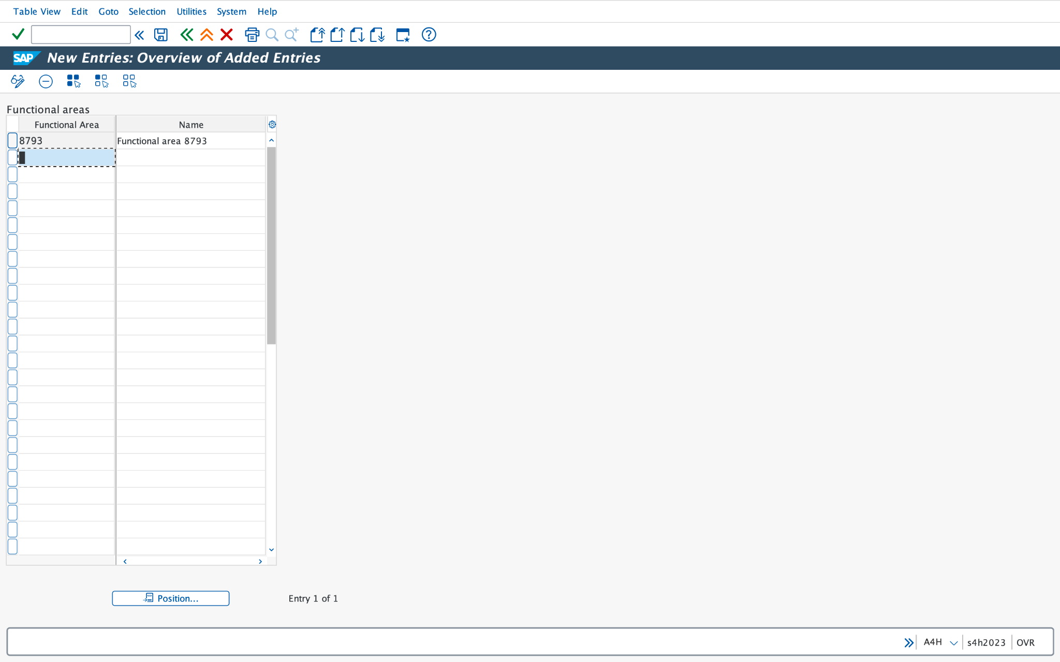

SAP TABLE FOR FUNCTIONAL AREA FM_FUNCTION:
TFKB

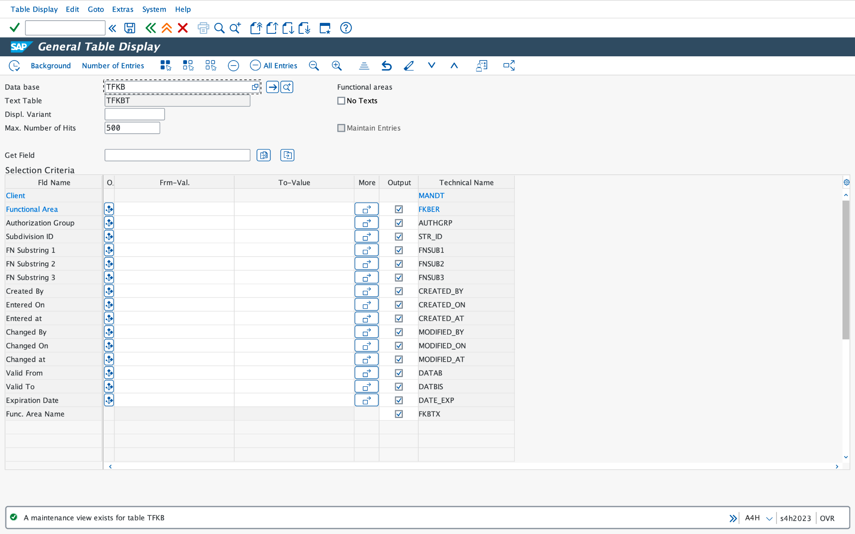

CREDIT CONTROL AREA CREATION:

SAP CONFIGURATION PATH:
SPRO > SAP Reference IMG > Enterprise Structure > Definition > Financial Accounting > Define Business Area

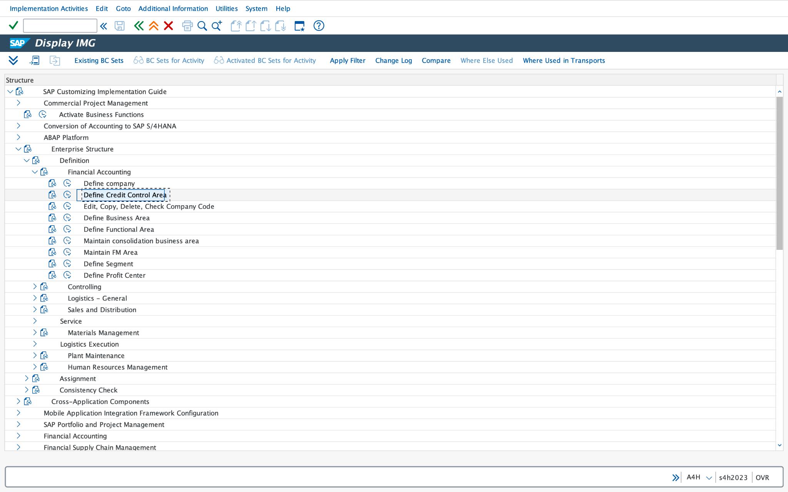

TRANSACTION CODE:

OB45

Required fields are shown in the image please fill up the required fields.

CREDIT CONTROL AREA FIELD (R): fill up the numeric value for respective credit control area field.

DATA FOR UPDATING SD (R/O):

Update (O): it is optional field

Fiscal Year Variant (R):
Add FV Variant for credit control area.

Default Data for Automatically Creating new Customers

Risk Category (O):it is optional field

Credit Limit (O):it is optional field

Rep. Group (O):it is optional field

ORGANIZATIONAL DATA (O):

All Company Codes (O):
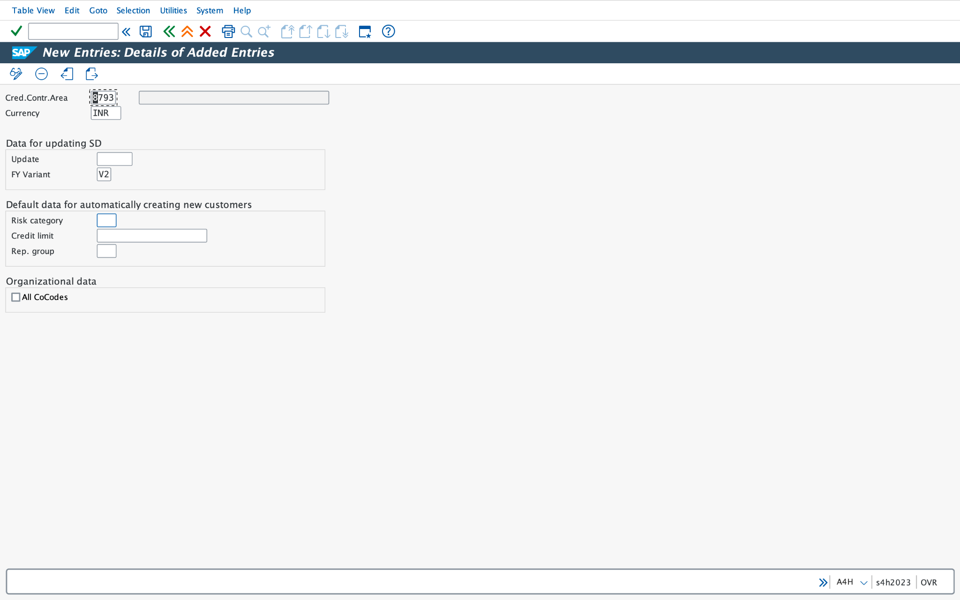

SAP TABLE FOR CREDIT CONTROL AREA OB45:

T014

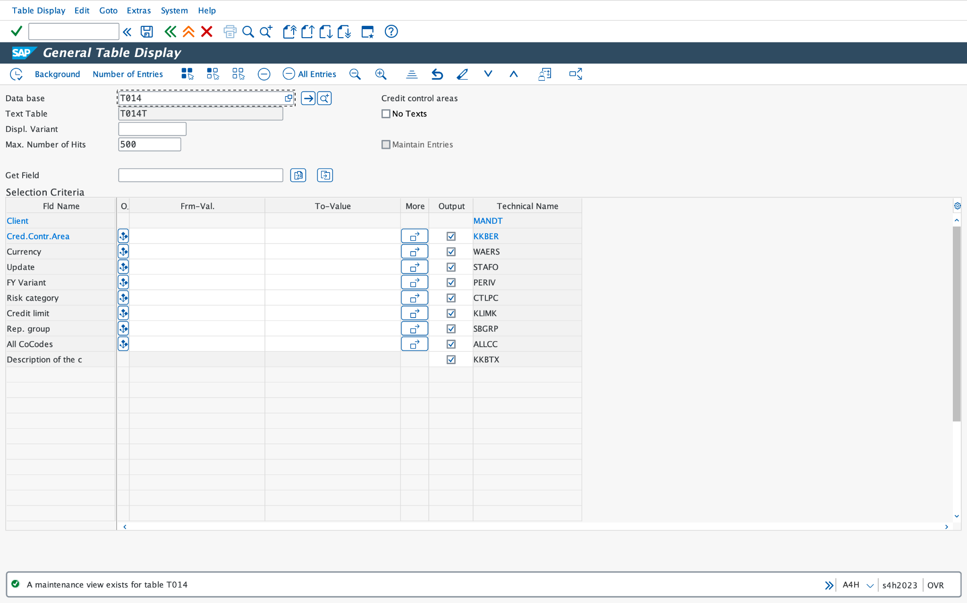

ASSIGN CREDIT CONTROL AREA TO COMPANY CODE:
OB38
SAP CONFIGURATION PATH:
SPRO > SAP Reference IMG > Enterprise Structure > Assignment > Financial Accounting > Assign Company Code to Credit Control Area.

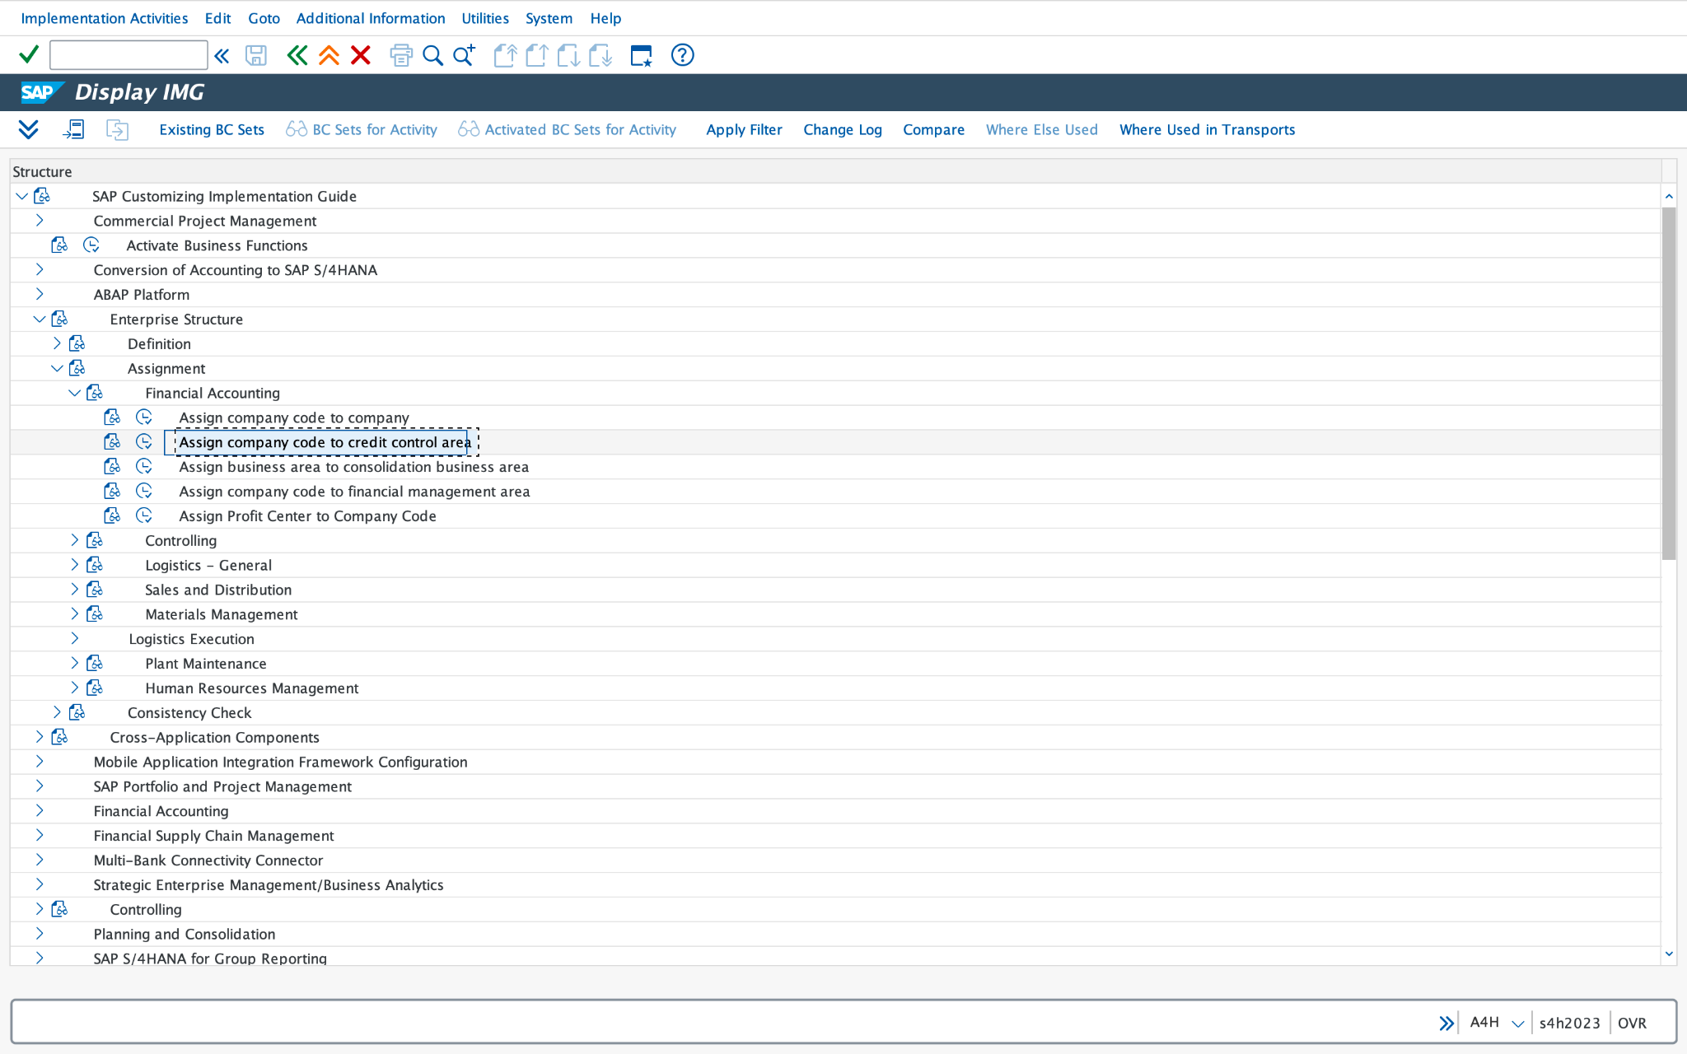

TRANSACTION CODE:
OB38
Please add credit control area number in field and save the data.

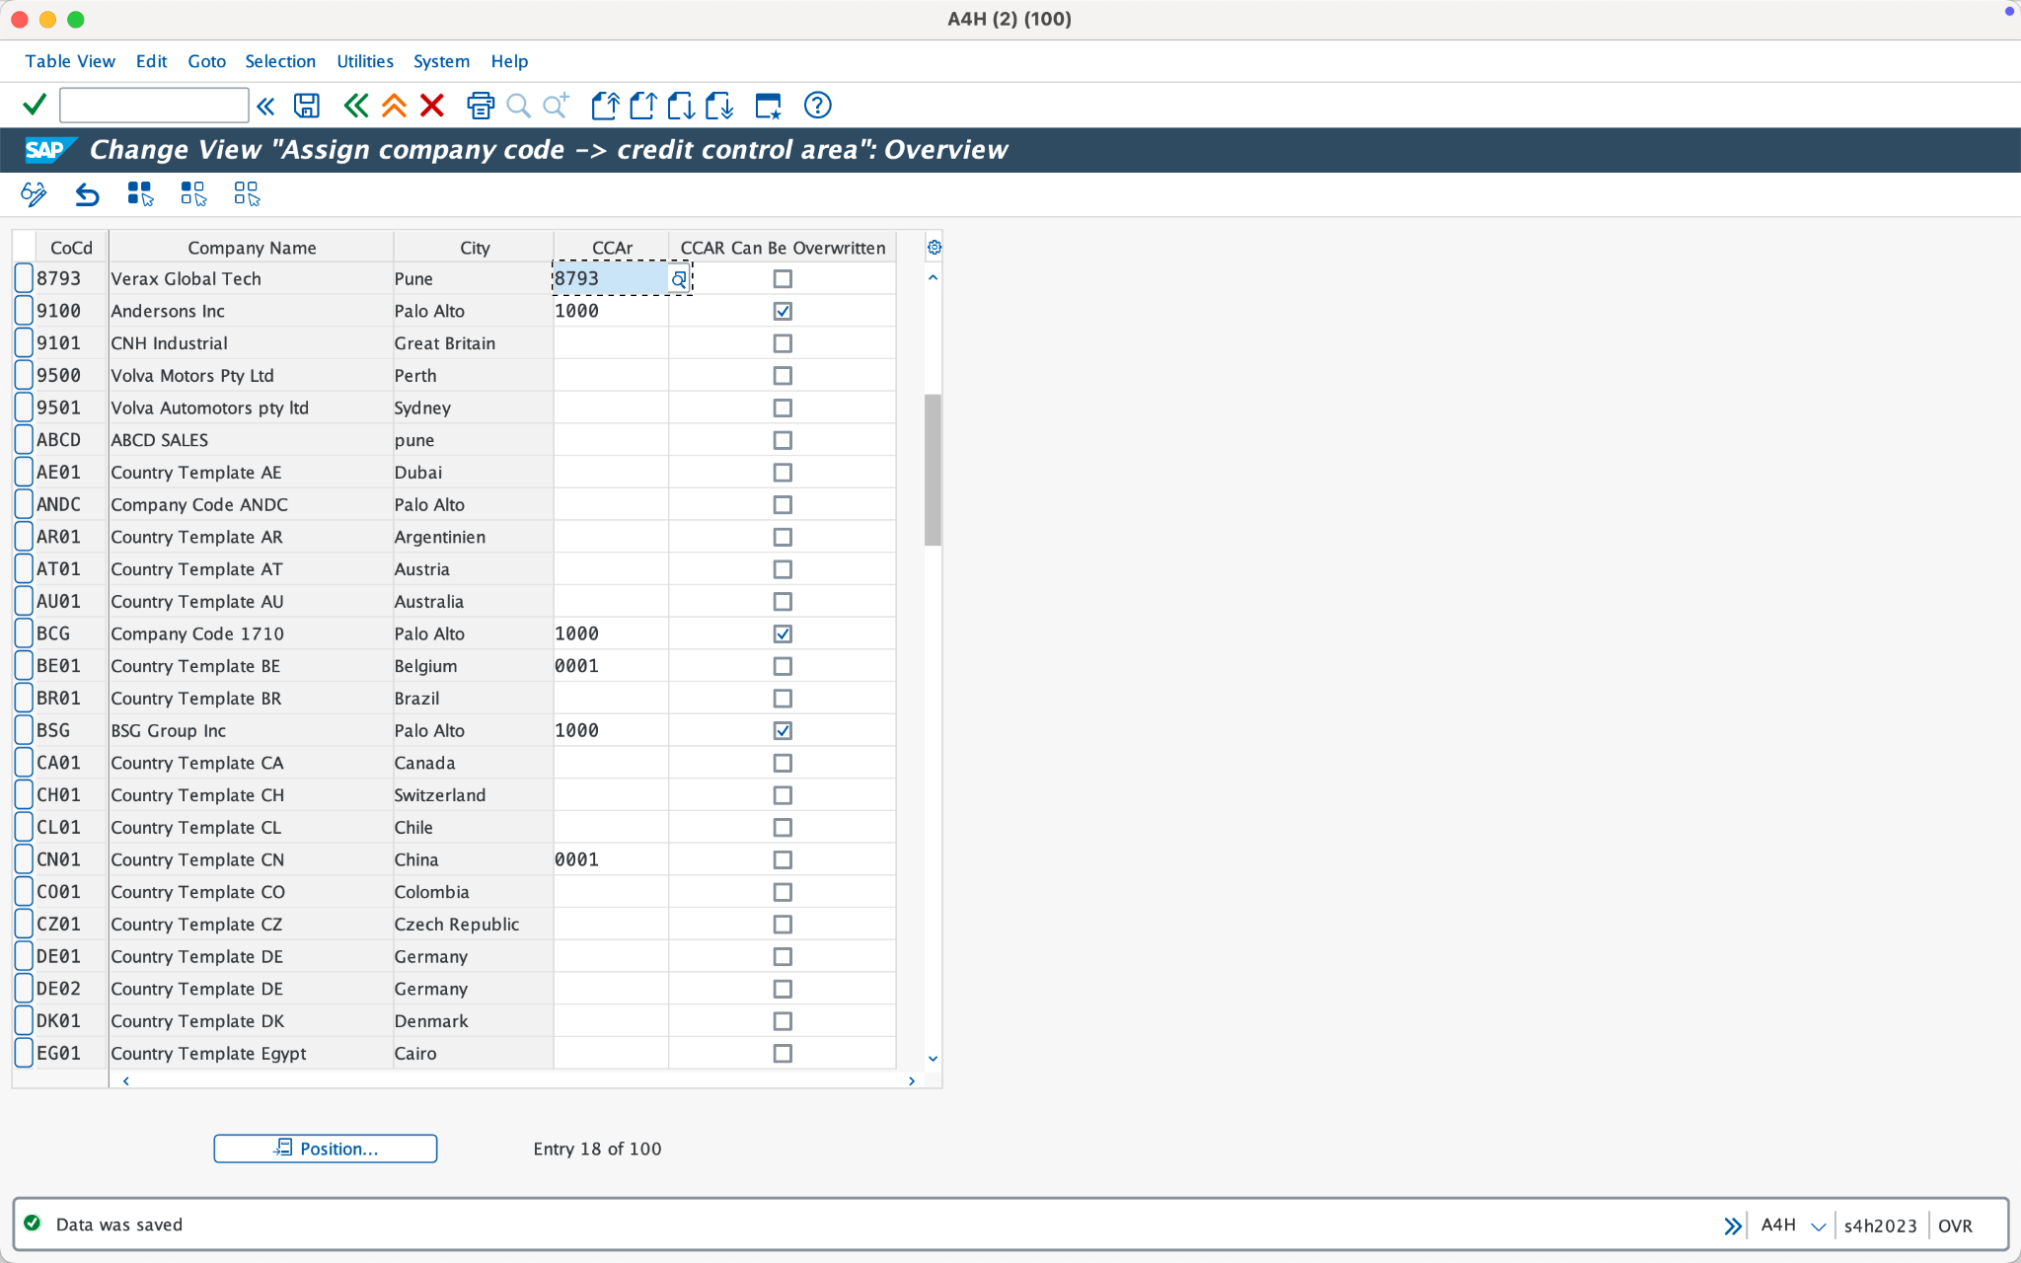

SAP TABLE FOR COMPANY CODE:
T001



CREDIT CONTROL AREA:

T014


